Customer Shopping Behavior Analysis
1. Project Overview:
This project analyzes customer shopping behavior using transcational data from 3900 purchases across various product categories. The goal is to uncover insights into spending patterns, customer segments, product preferences and subscription behavior to guide strategic Business decisions.
2. Dataset Summary:
- Rows: 3900
- Columns: 18
- Key features:
- Customer demographics (Age, Gender, Location, Subscription Status)
- Purchase details (Item Purchased, Category, Purchase Amount, Season, Size, Color)
- Shopping Behavior (Discount Applied, Promocode Used, Previous Purchases, Frequency Purchases, Review Rating, Shipping Type)
- Missing Data: 37 values in Review Rating Column.

3. Exploratory Data Analysis using Python:
We began with data preparation and cleaning in Python:
- Data Loading : Imported the dataset using pandas.
- Initial Exploration : Used df.info() to check structure and .describe() for summary statistics.
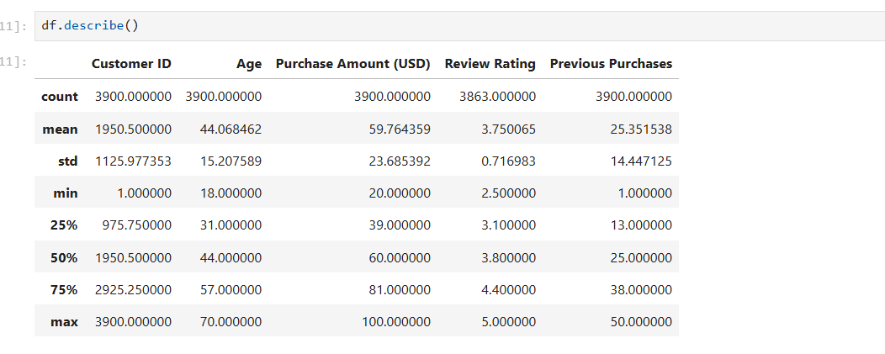
- Missing Data Handling : Checked for null values and imputed missing values in Review Rating column using median rating of each product category.
- Column Standardization: Renamed columns to snake case for better readability.
- Feature Engineering:
  - Created age_group column by binning customer ages.
  - Created purchase_frequency_days column form purchase data.
- Data Consistency check: Verified if discount_applied and promo_code_used
Were redundant, dropped promo_code_used.
- Database Integration : Connected Python script to PostgreSQL and loaded the cleaned DataFrame into the database for SQL Analysis.
4. Database Analysis using SQL (Business Transaction)
We performed structured analysis in PostgreSQL to answer key business questions:
1. Revenue by Gender – Compared total revenue generated by gender.
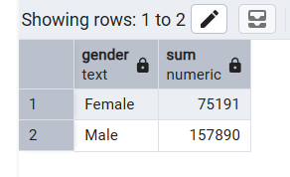
2. High spend discount users – Identified customers who used discounts but still spent above average purchase amount.
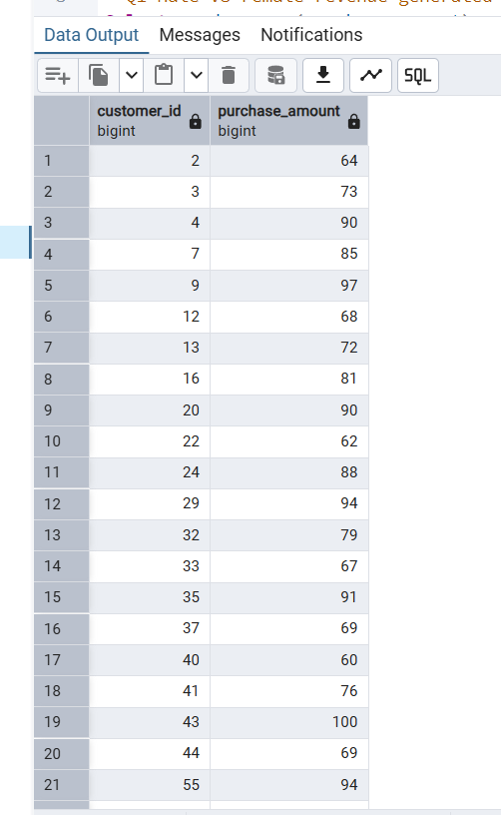
3. Top 5 products by Rating – Found products with highest average review rating.
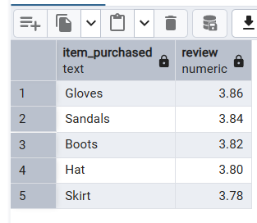
4. Shipping Type Comparison – Compared average purchase amounts between Standards and Express Shipping.
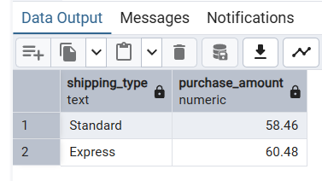
5.Subscribers Vs Non-Subscribers – Compared average spend and total revenue across subscription status.
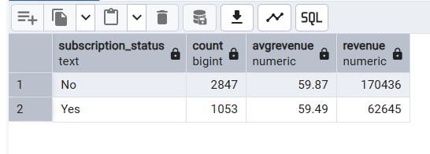
6. Discount – Dependent Products – Identified 5 products with the highest percentage of discounted purchases.
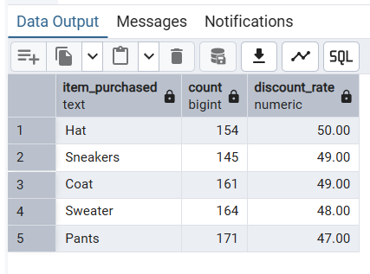

7.Customer Segmentation – Classified customers into New. Returning, and Loyal segments based on purchase history.
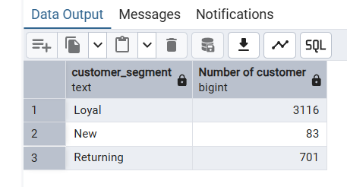
8. Top 3 products per category – Listed the most purchased products within each category.
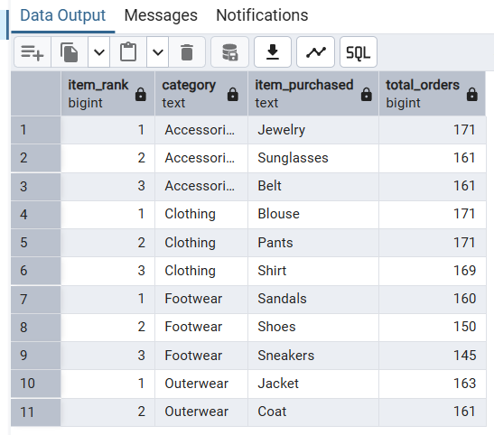

9. Are customers who are repeat buyers (more than 5 previous purchases) also likely to subscribe?
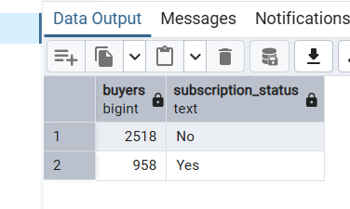
10. Revenue contribution of each age group
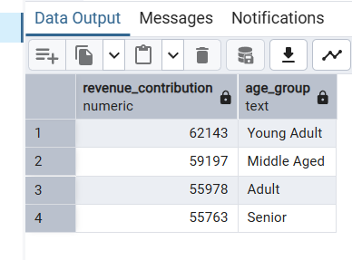

5. Dashboard created in PowerBI :
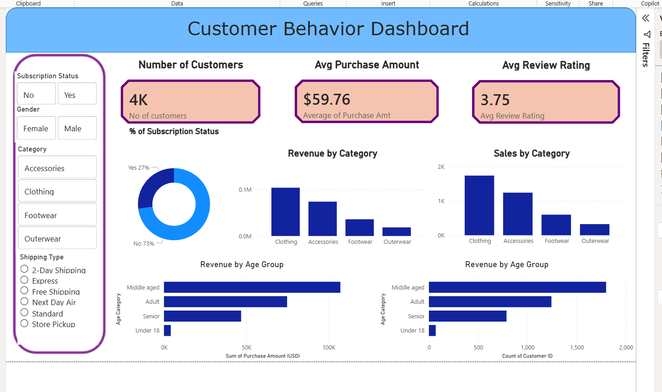

6. Business Recommendations:
- Drive Subscription Growth – Promote exclusive subscriber benefits and personalized offers to increase conversions and retention.
- Strengthen Customer Loyalty – Implement a structured rewards program to encourage repeat purchases and transition customers into high-value loyalty segments.
- Optimize Discount Strategy – Reassess discount policies to balance revenue growth with margin protection and long-term profitability.
- Enhance Product Positioning – Prioritize top-rated and best-selling products in marketing campaigns to maximize visibility and conversion rates.
- Refine Targeted Marketing – Focus campaigns on high-revenue customer segments, including key age groups and express shipping users, to improve ROI.

